Panaxia continues its upward trend
Ends Q3 with record revenues of 16.8 million
and 300% growth over the previous year

Revenues for the first nine months of the year were up by 400%, amounting to 43.8 million

55% growth in gross profit and lower operating and net losses in Q3 compared to Q2

Recently reported several strategic achievements, with the foremost among them being the receipt of a marketing permit in Germany for its series of medical cannabis products, first commercial export of inflorescence to Australia, and additional export permits for Australia and Portugal with partner growers

Expanding its collaboration with pharmaceutical titan, Neuraxpharm, into France and preparing to begin export and initial sales in Germany by year-end

(Tel Aviv, November 29, 2020) - The Israeli subsidiary of Panaxia Global, Panaxia Labs Israel Ltd. (“Panaxia Israel,” TA: PNAX), Israel’s largest manufacturer of medical cannabis products, today announced its financial results for the third quarter and first nine months of 2020.

Dr. Dadi Segal, Founder and CEO of Panaxia said, “We are delighted to close out the third quarter of the year with another record for growth in revenues from our operations in the Israeli market along with continued improvement in gross profitability and lower net losses. The welcome change in the Ministry of Health’s policy in the current quarter, with approval to open the market for exports, finally makes it possible for Panaxia to realize its vision to become a leading pharmaceutical player in the global medical cannabis market. Our many important recent achievements following our receipt of the marketing permit in Germany for our products along with first commercial exports to Australia and additional export permits for Australia and Portugal, are laying the groundwork for us to implement Panaxia’s strategic business program in the coming years.”
Panaxia Israel - revenues in millions:
2018-2020 quarterly revenues
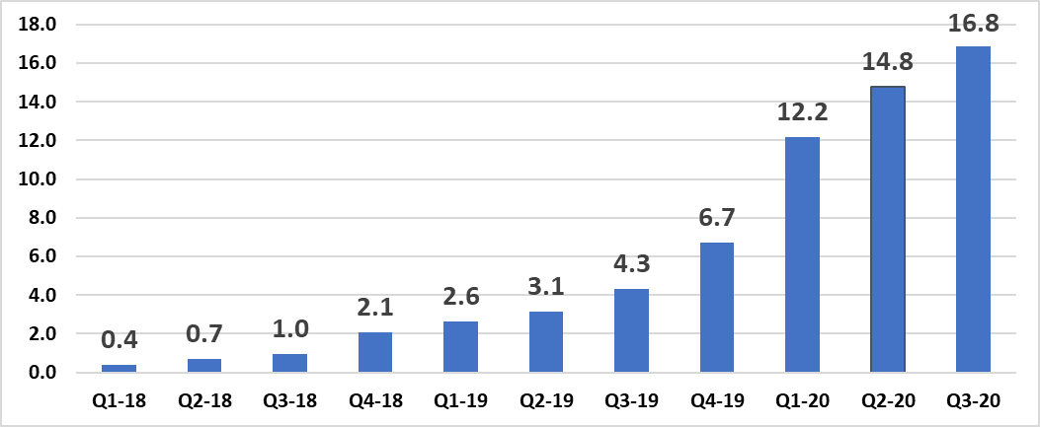

Results for the third quarter and first nine months of 2020:
The company's revenues in the third quarter of 2020 amounted to a record 16.8 million, 293% growth compared to revenues of 4.3 million in the corresponding quarter the previous year, and 14% growth compared to 14.8 million in revenues in the second quarter of 2020. Panaxia's revenues in the first nine months of 2020 amounted to 43.8 million, 337% growth compared to revenues of 10.0 million in the corresponding period the previous year. Panaxia’s revenues in 2019 amounted to 16.7 million.
The growth in revenue is attributable to the growth in sales of finished goods in the Israeli market, both Panaxia’s own brands, including the premium brand, Axiban, a collaborative effort by Panaxia and Rafa, and third-party brands, through home deliveries, under the new regulation, and from significant growth in production of products that were packaged and processed at the company's facility, as well as their storage and distribution. Provision of manufacturing services and sales of products for patients under the new regulation are yielding significantly higher revenues for Panaxia than the provision of the same services under the old regulation.

Gross profit in the third quarter of 2020, under the new regulation, amounted to 1.9 million (rate of gross profit of 11.2%) compared to gross losses of 530,000 in the corresponding quarter of the previous year under the old regulation.

The improvement in profit and gross profitability in the quarter and in the period is primarily attributable to the growth in the scale of activity in the Israeli market and leveraging of economies of scale both for variable expenses and in covering fixed expenses. This goes hand in hand with the growth in costs required for Panaxia to comply with two standards - Israel IMC-GMP and EU-GMP certification from a European health authority in June 2020, which will allow Panaxia to export its products to European countries. Additionally, growth in variable production costs due to an increase in total production and growth in the cost of the finished goods that are sold to patients under the new regulation.
Panaxia believes that the upward trend in profitability will continue along with commercial exports and the start of sales, in light of the strong profitability of the products sold in global markets compared to those sold in the Israeli market.

About Panaxia Israel
Panaxia Labs Israel, Ltd. is a publicly-traded company at TASE (TASE: PNAX). It is the largest Israeli manufacturer and home-delivery distributor of medical cannabis products, and the first to have received the approval of the Israeli Ministry of Health for the manufacturing of medicinal cannabis-based pharmaceuticals (under the IMC-GMP directive) as well as EU-GMP standard certification required for commercial production and export of medical cannabis and its products to Europe. The company manufactures over 30 hemp-based medicinal products and has accumulated a broad foundation of clinical experience based on tens of thousands of patients.

Panaxia is a subsidiary of the Segal Pharma Group, owned by the Segal family and founded over forty years ago. The company manufactures over 600 different pharmaceutical products that are distributed in over 40 countries worldwide.
visit the Panaxia website at https://panaxia.co.il/

For more information:
Noa Leviel
Lnoa@ibh.co.il

