Panaxia continues to grow:

*Panaxia Global Reports that Panaxia Israel ended the 3rd quarter of 2020 with record revenues of at least 16.3 million, growing by over three times YoY*

*Completes 12 consecutive quarters of revenue increase*

*Projects to complete the first nine months with revenues of at least 43.2 million, an increase of over 330% YoY*

*Prepared to start commercial export to Germany by the yearend, pending an export permit from Israel Health Authority*

**(Tel-Aviv, October 12, 2020)** The Israeli subsidiary of Panaxia Global, **Panaxia Labs Israel Ltd.** (**Panaxia Israel, TASE: PNAX**), the largest manufacturer of medical cannabis products in Israel, issued today a preliminary revenue outlook for the 3rd quarter of 2020. The Company estimates its unaudited consolidated revenues in the 3rd quarter of 2020 will be at least 16.3 million.

The above guidance reflects the company’s continued growth in the Israeli market, reflecting a growth rate of 279%, or over three times, from its revenues in the same quarter of last year (4.3 million). In 2019, Panaxia Israel reported total revenues of 26.7 million, whereas, in the second quarter of 2020, it reported revenues of 14.8 million. The revenues of the 3rd quarter reflect an increase of more than 10%, driven by the larger number of patients and the scope of products manufactured by the company.

Based on these estimates, the company projects that its revenues for the first nine months of 2020 will amount to at least 43.2 million, an increase of more than 330% over the first nine months of 2019, which totaled 10 million.

**Panaxia Israel: quarterly revenues in millions, 2018-2020**

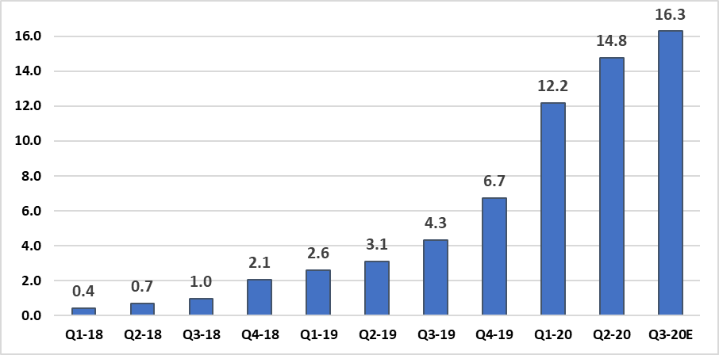

|  |  |
| --- | --- |
|  |  |

**About Panaxia Israel**

Panaxia Labs Israel, Ltd. is a publicly-traded company at TASE (TASE:PNAX). It is the largest Israeli manufacturer and home-delivery distributor of medical cannabis products, and the first to have received the approval of the Israeli Ministry of Health for the manufacturing of medicinal cannabis-based pharmaceuticals (under the IMC-GMP directive) as well as EU-GMP standard certification required for commercial production and export of medical cannabis and its products to Europe. The company manufactures over 30 hemp-based medicinal products and has accumulated a broad foundation of clinical experience based on tens of thousands of patients.

Panaxia is a subsidiary of the Segal Pharma Group, owned by the Segal family and founded over forty years ago. The company manufactures over 600 different pharmaceutical products that are distributed in over 40 countries worldwide.

visit the Panaxia website at <https://panaxia.co.il/>

**For more information**:  
Noa Leviel   
[Lnoa@ibh.co.il](mailto:Lnoa@ibh.co.il)