Panaxia Global Reports Record Revenues of its Israeli operations:
The preliminary outlook projects at least 14 million in Q2 2020.
Completes 11 consecutive quarters of growing revenues

Predicts revenues will increase by more than 350% over the same quarter of last year and by 15% over Q120

Reports the receipt of EU-GMP standard certification required for commercial production and exports of medical cannabis and its products to Europe.
Expects to start sales in Germany and Denmark in H2 2020

Tel Aviv, 8 July 2020 - The Israeli subsidiary of Panaxia Global, Panaxia Labs Israel Ltd. (Panaxia Israel, TASE: PNAX), the largest manufacturer of medical cannabis products in Israel, issued today a preliminary revenue outlook for the second quarter of 2020. The company estimates its consolidated (non-reviewed) revenues in the second quarter of 2020 will be at least 14 million.
The projected revenues for the second quarter reflect the continued growth of the company’s operations with a 350%-increase of revenues in the second quarter of 2019, which totaled 3.1 million. Compared with the revenues of Q1 2020 of 12.2 million, the projected revenues for Q2 2020 reflect an increase of over 15%.
Based on these projections, the company’s revenues in the first half of 2020 are expected to total at least 26.2 million, an increase of 357% compared with the revenues in the first half of 2019, which totaled 5.7 million.
Dr. Dadi Segal, CEO of Panaxia Global, said, “We are happy to end another quarter of record revenue, which complete 11 consecutive quarters of increased revenues. The consistent growth reflects the expansion of our operations in the Israeli market, as well as a strong vote of confidence on behalf of our patients. Concurrently, we prepare to start selling in Europe in the second half of 2020 as the first Israel medical cannabis company that is certified with EU-GMP standard for production and export of both raw materials and finished products. The EU-GMP, strategic marketing and distribution agreements entered in Europe, progress made towards completion of the production facility in Malta, and the expected receipt of regulatory marketing approvals in Germany, position Panaxia as the company that opened the door to Europe for the Israeli cannabis industry.
We look forward to achieving this important goal concurrently with continued growth in Israel.”

Panaxia Israel: quarterly and annual revenues, in millions:
Quarterly revenues, 2017-2020, in millions | Cumulative revenues, 2017-2020, in millions
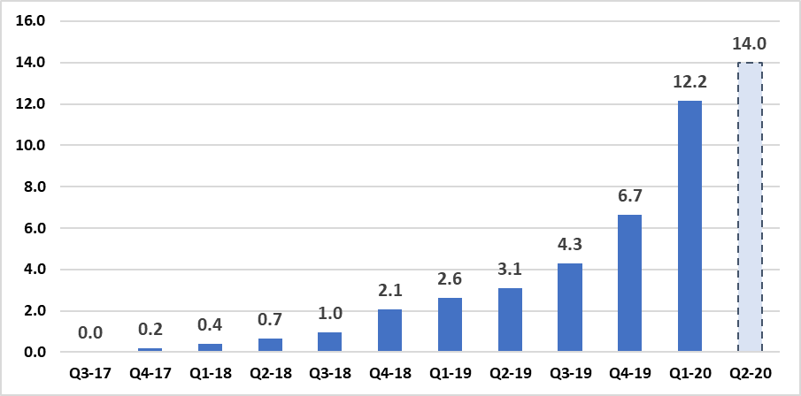
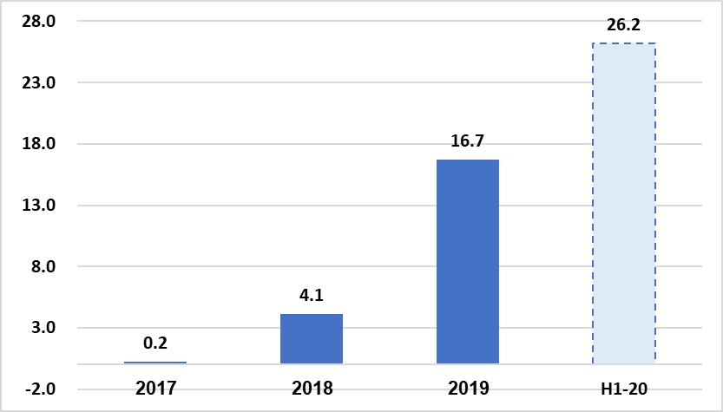

The revenue figures for the second quarter of 2020 are based on the management’s estimates at this stage and have not been audited or reviewed.
About Panaxia Israel
Panaxia Labs Israel, Ltd. is a publicly-traded company at TASE (PNAX). It is the largest Israeli manufacturer and home-delivery distributor of medical cannabis products, and the first to have received the approval of the Israeli Ministry of Health for the manufacturing of medicinal cannabis-based pharmaceuticals (under the IMC-GMP directive) as well as EU-GMP standard certification required for commercial production and export of medical cannabis and its products to Europe. The company manufactures over 30 hemp-based medicinal products and has accumulated a broad foundation of clinical experience based on tens of thousands of patients.
Panaxia is a subsidiary of the Segal Pharma Group, owned by the Segal family and founded over forty years ago. The company manufactures over 600 different pharmaceutical products that are distributed in over 40 countries worldwide. Panaxia Labs Israel is a subsidiary of Panaxia Pharmaceutical Industries, co-founded by Dr. Dadi Segal, Dr. Eran Goldberg, and Adv. Assi Rotbart as the cannabis division of the Segal Pharma Group. A sister subsidiary, Panaxia US, manufactures in North America over 60 hemp-based medicinal products, including sublingual tablets, lozenges, oils, and inhalators designed for treating conditions such as PTSD, cancer, chronic pain, epilepsy, anorexia, burns, and many other ailments. Panaxia Group has over 150 employees, who also conduct all of its clinical trials.
The Segal Pharma Group additionally owns Luminera Derm, manufacturer of injectable dermal fillers, and Tree of Life Pharma, manufacturer of over-the-counter drugs. For more information, visit the Panaxia website at https://panaxia.co.il/
For more information:
Noa Leviel
Lnoa@ibh.co.il
972-50-869-18

