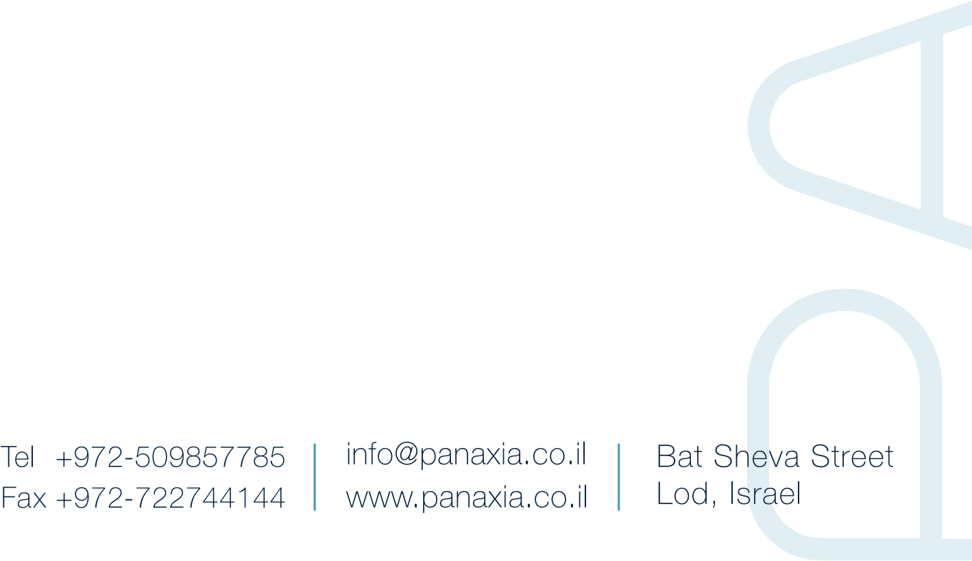
A senior investment banker at Wall Street joins Panaxia:

Orit Freedman Weissman, former partner at Goldman Sachs New-York, has been appointed Director in Panaxia

Dr. Dadi Segal, Panaxia CEO and Founder: "Orit's extensive knowledge of markets world-wide will further assist the company, which stands on the verge of becoming a global company"

(Tel-Aviv, May 29th, 2019) – Panaxia Israel Pharmaceutical Industries, the largest pharmaceutical cannabis company in Israel, announced today that Orit Freedman Weissman, a senior investment banker at Wall Street, has been appointed Director in Panaxia.
Freedman Weissman, former partner at Goldman Sachs Investment Banking for 24 years, specialized in Mergers & Acquisitions, raising capital, debts, and investments in private companies. She established and headed Goldman Sachs Israel Group, and served on the Global Advisory Board of Goldman Sachs. Orit is a graduate of Tel Aviv University Law School, and earned an MBA at New York University's Stern School of Business.

Orit Freedman Weisman said today: "I see great potential for growth in the global pharmaceutical cannabis sector. I believe in Panaxia's abilities of becoming a leading company in the global market, based on the company's unique knowledge and experience. The company's management team is quite impressive and I am thrilled to join the team and further assist the company in developing and substantiating it's position in the global market."

Dr. Dadi Segal, Panaxia CEO and Founder, added that "The fact that Orit joined our Directorate is a vote of confidence in Panaxia's abilities and business potential. Orit has over 25 years of experience as a Senior Consultant to CEOs, Directorates and investors, in cross-industry global enterprises. Her extensive knowledge of markets world-wide will further assist Panaxia, which stands on the verge of becoming a global company."
About Panaxia
Panaxia Israel develops drugs based on pharmaceutical cannabis and manufactures dozens of products based on pharmaceutical cannabis in its production plants in Lod. The company is part of the pharmaceutical group of the Segal family, operating for over four decades, and manufacturing over 600 different pharmaceutical products, which it distributes in over 40 countries. Panaxia was founded by Dr. Dadi Segal, Dr.Eran Goldberg and Assi Rotbart, LL.b, and constitutes the Group's cannabis division. In addition, the sister-division of North America manufactures over 60 pharmaceutical products based on medical cannabis, including sublingual tablets, oral tablets, oils, inhalers, and more, intended to treat conditions such as post-traumatic stress, cancer, chronic pains, epilepsy, anorexia, burns, and many other medical conditions. Panaxia employs around 100 employees and all clinical experiments are conducted by the company. The pharmaceutical group of the Segal family includes the Luminera divisions, which manufacture wrinkle filler injections, and TREE OF LIFE, which manufactures non-prescription drugs.

